 

|  |  |
| --- | --- |
|  |  |

Data Compliance Test (DCT)

Test Cases for

Radiology Examination

*<HCP Name>*

Table of Contents

1. Testing Instructions to HCPs 3

1.1 Self-Service Testing Phase 3

1.2 Final Testing Phase 3

1.3 Preparation of DCT Test Report 4

2. Test Case Details 5

RAD-LV3-001 [FOR LEVEL 3 DATA UPLOAD ONLY] 5

RAD-LV3-002 [FOR LEVEL 3 DATA UPLOAD ONLY] 17

RAD-LV2-001 [FOR LEVEL 2 DATA UPLOAD ONLY] 30

RAD-LV2-002 [FOR LEVEL 2 DATA UPLOAD ONLY] 38

RAD-LV1-001 [FOR LEVEL 1 DATA UPLOAD ONLY] 46

RAD-LV1-002 [FOR LEVEL 1 DATA UPLOAD ONLY] 51

3. Appendix – Sample Messages 58

4. Appendix – Testing HCP and HCRs Information 61

5. Appendix – Sample Results in eHR Viewer (EVE) 62

6. Appendix – Actual Data Values (Sample) 72

# Testing Instructions to HCPs

## Self-Service Testing Phase

* After development of the data upload programmes, you can use the **Self-Service test accounts and test HCRs** provided by eHealth for connection to the eHealth testing environment and proceed with the self-service testing.
* You can proceed with the Self-service test at your own pace by following this Self-Service Testing Guide and using the test cases provided in section 2.
* You can verify the **correctness** and **completeness** of the data upload by:
  + checking the interface files / messages generated in your system against the sample expected results of interface files /messages for all test cases as provided;
  + checking the results on eHR Viewer (EVE) by logging into the testing eHealth with the provided test account; and
  + checking the upload status through Process Summary and Exception Report in eHR Inbox by logging into the testing eHealth.
* For data fields requiring eHR Codex values, you can refer the Code Sets provided with the Self-Service Kit.
* For details of technical requirements of the data interface files, please refer to the ‘Developer Quick Guide for Radiology Examination Data Upload to eHealth.docx’.
* You are required to perform the test cases that are relevant to the data compliance level (Level 1, 2 or 3) supported by your clinic.
* You are required to perform the first batch of data upload by **Data Materialization** (**DM**) mode. **DM mode** is denoted in the interface by a fixed value **BL-M** in *HL7 OBX.4*
* You should use **Incremental Load** (**INC**) mode for the second batch of data upload to update the previously uploaded records. **INC mode** is denoted in the interface by a fixed value **BL** in *HL7 OBX.4.*
* Since the **DM** mode would replace the corresponding records previously uploaded to eHealth, you may repeat your testing unlimited number of times by uploading the first batch by **DM** mode.
* When all required test cases can be completed smoothly and correctly in this phase, you can proceed to the Final Testing Phase and submit **production environment setup form** to eHR DCT Support for preparation.

## Final Testing Phase

* You can start the Final Testing Phase once all test cases in the Self-Service Testing phase are passed.
* You should start Final Test by executing the test cases provided in section 2 with **Final Testing HCRs** provided by eHR DCT Support.
* You can verify the **correctness** and **completeness** of testing results by checking results in eHR Viewer (EVE) and the upload status through Process Summary, Exception Report and Regrade Report in eHR Inbox.
* For Radiology Examination DCT test cases, there are **TWO** batches of data files / transactions to be uploaded to the testing
* eHealth. The required records must be correctly uploaded from these 2 consecutive batches respectively.
* The Final Test will be considered PASSED if all the following criteria are met:
  + The TWO batches of test data files are uploaded consecutively in the correct sequence. The second batch of data files/transactions must be submitted after completion of processing of the first batch by eHealth.
  + No additional data files / transactions are uploaded in between or after the uploads of the above two batches of data files / transactions to amend any records.
  + No exception records are reported from the uploads.
  + No manual interventions have been made to the data files / transactions.
* If the Final Test failed, you can re-attempt the Self-Service Test and Final Test until a successful run can be completed.

## Preparation of DCT Test Report

* Once you have successfully passed the Final Test based on the above criteria, you should complete this document by attaching the below items to this document at the appropriate space provided:
  + Actual data files uploaded
  + Screen-shot of each test case
* You are required to submit this completed ‘DCT Test Cases’ document to eHR DCT Support for further processing. eHR DCT Support will provide feedback **within 10 working days**.

# Test Case Details

* + *RAD-LV3-001 and RAD-LV3-002 : Only applicable for testing level 3 data upload*
  + *RAD-LV2-001 and RAD-LV2-002 : Only applicable for testing level 2 data upload*
  + *RAD-LV1-001 and RAD-LV1-002 : Only applicable for testing level 1 data upload*
  + *Please complete and collect the upload results for RAD-xxx-001 before proceeding to RAD-xxx-002.*

| **1** | **Test Case ID** | RAD-LV3-001 [FOR LEVEL 3 DATA UPLOAD ONLY] | |
| --- | --- | --- | --- |
|  | **Function Description** | HCP has received the sharing consents from testing HCRs, then perform first data upload of HCRs’ clinical records to eHealth by DM Mode for level 3 data. | |
| **Subsequent case of** | N/A | |
| **Testing Assumption** | * HCR1-HCR6 have already given sharing consents to the HCP. * The EMR system (EMRS) will upload Batch 1 data files to eHealth with all radiology examination of <HCR1> - <HCR6> created by DM mode. | |
| **Test Actions** | HCP creates below radiology examination in EMR system: | |
| 1a | Case scenario: Input new radiology examination with *valid* code set for <HCR1> in EMRS for PDF report generation as follows:   * Radiology request healthcare institution local name = [source system provided] * Radiology registration datetime = “30-May-2024 15:00:00” * Radiology examination datetime = “30-May-2024 15:30:00“ * Radiology modality code = “XRAY” * Radiology examination name = “X-Ray Chest (PA or AP View)” * Radiology examination performing institution local name = [source system provided] * Radiology examination healthcare staff English name= [source system provided] * Radiology examination healthcare staff type local description = “Chief healthcare staff of the procedure” * Radiology report title = “Radiology Report” * Radiology report date = “30-May-2024” * Radiology report – reported by healthcare staff English name = [source system provided]   == Actual data values (Refer to “Appendix - Actual Data Values (Sample)” for details)  Expected data contents for Level 3 interface record:   * Radiology request healthcare institution identifier = [source system provided] * Radiology request healthcare institution long name = [source system provided] * Radiology request healthcare institution local name = [source system provided] * Referral no. = [source system provided] * Radiology registration datetime = “30-May-2024 15:00:00” * Radiology registration no. = [source system provided] * Radiology examination datetime = “30-May-2024 15:30:00“ * Radiology modality code = “XRAY” * Radiology examination name = “X-Ray Chest (PA or AP View)” * Radiology examination performing institution identifier = [source system provided] * Radiology examination performing institution long name = [source system provided] * Radiology examination performing institution local name = [source system provided] * Radiology examination healthcare staff English name= [source system provided] * Radiology examination healthcare staff type code = “C” * Radiology examination healthcare staff type description = “Chief healthcare staff of the procedure” * Radiology examination healthcare staff type local description = “Chief healthcare staff of the procedure” * Radiology report title = “Radiology Report” * Radiology report date = “30-May-2024” * Radiology report – reported by healthcare staff English name = [source system provided] * Radiology report (Text) = null * File indicator = 1 * File name of Radiology report = [follow naming standards as specified in General Guide] * Radiology Report (PDF) = Generated PDF report with the above data and file name * DICOM image accession no. = [source system provided] |
| 1b | **Case scenario**: Input new radiology examination with *invalid* code set for <HCR2> in EMRS for PDF report generation as follows:   * Radiology request healthcare institution local name = [source system provided] * Radiology registration datetime = “10-Apr-2024 14:00:00” * Radiology examination datetime = “10-Apr-2024 14:30:00“ * Radiology modality code = “BI” * Radiology examination name = “Mammography 2D Bilateral” * Radiology examination performing institution local name = [source system provided] * Radiology examination healthcare staff English name= [source system provided] * Radiology examination healthcare staff type local description = “Chief healthcare staff of exam” * Radiology report title = “Radiology Report” * Radiology report date = “10-Apr-2024” * Radiology report – reported by healthcare staff English name = [source system provided]   == Actual data values (Refer to “Appendix - Actual Data Values (Sample)” for details)  Expected data contents for Level 3 interface record:   * Radiology request healthcare institution identifier = [source system provided] * Radiology request healthcare institution long name = [source system provided] * Radiology request healthcare institution local name = [source system provided] * Referral no. = [source system provided] * Radiology registration datetime = “10-Apr-2024 14:00:00” * Radiology registration no. = [source system provided] * Radiology examination datetime = “10-Apr-2024 14:30:00“ * Radiology modality code = “BI” * Radiology examination name = “Mammography 2D Bilateral” * Radiology examination performing institution identifier = [source system provided] * Radiology examination performing institution long name = [source system provided] * Radiology examination performing institution local name = [source system provided] * Radiology examination healthcare staff English name= [source system provided] * Radiology examination healthcare staff type code = “C” * Radiology examination healthcare staff type description = “Chief healthcare staff of exam” * Radiology examination healthcare staff type local description = “Chief healthcare staff of exam” * Radiology report title = “Radiology Report” * Radiology report date = “10-Apr-2024” * Radiology report – reported by healthcare staff English name = [source system provided] * Radiology report (Text) = null * File indicator = 1 * File name of Radiology report = [follow naming standards as specified in General Guide] * Radiology Report (PDF) = Generated PDF report with the above data and file name * DICOM image accession no. = [source system provided]   *Remark: Record will show in “Re-grade Report” as Radiology examination healthcare staff type description not matched the eHR description of Radiology examination healthcare staff type code in IAMS.* |
| 1c | **Case scenario:** Input new radiology examination with *valid* code set for <HCR3> in EMRS for text report generation (No PDF) as follows:   * Radiology request healthcare institution local name = [source system provided] * Radiology registration datetime = “3-Jun-2024 10:00:00” * Radiology examination datetime = “3-Jun-2024 10:30:00“ * Radiology modality code = “XRAY” * Radiology examination name = “Abdomen” * Radiology examination performing institution local name = [source system provided] * Radiology examination healthcare staff English name= [source system provided] * Radiology examination healthcare staff type local description = “Chief healthcare staff of the procedure” * Radiology report title = “Radiology Report” * Radiology report date = “3-Jun-2024” * Radiology report – reported by healthcare staff English name = [source system provided]   == Actual data values (Refer to “Appendix - Actual Data Values (Sample)” for details)  Expected data contents for Level 3 interface record:   * Radiology request healthcare institution identifier = [source system provided] * Radiology request healthcare institution long name = [source system provided] * Radiology request healthcare institution local name = [source system provided] * Referral no. = [source system provided] * Radiology registration datetime = “3-Jun-2024 10:00:00” * Radiology registration no. = [source system provided] * Radiology examination datetime = “3-Jun-2024 10:30:00“ * Radiology modality code = “XRAY” * Radiology examination name = “Abdomen” * Radiology examination performing institution identifier = [source system provided] * Radiology examination performing institution long name = [source system provided] * Radiology examination performing institution local name = [source system provided] * Radiology examination healthcare staff English name= [source system provided] * Radiology examination healthcare staff type code = “C” * Radiology examination healthcare staff type description = “Chief healthcare staff of the procedure” * Radiology examination healthcare staff type local description = “Chief healthcare staff of the procedure” * Radiology report title = “Radiology Report” * Radiology report date = “3-Jun-2024” * Radiology report – reported by healthcare staff English name = [source system provided] * Radiology report (Text) = <Text report with the above data> * File indicator = 0 * File name of Radiology report = null * No PDF Radiology Report generated * DICOM image accession no. = [source system provided] |
| 1d | **Case scenario:** Input new radiology examination with *invalid* code set for <HCR4> in EMRS for text report generation (No PDF) as follows:   * Radiology request healthcare institution local name = [source system provided] * Radiology registration datetime = “8-Jul-2024 11:00:00” * Radiology examination datetime = “8-Jul-2024 11:30:00“ * Radiology modality code = “CT” * Radiology examination name = “Hand (Plain)” * Radiology examination performing institution local name = [source system provided] * Radiology examination healthcare staff English name= [source system provided] * Radiology examination healthcare staff type local description = “Chief healthcare staff of exam” * Radiology report title = “Radiology Report” * Radiology report date = “8-Jul-2024” * Radiology report – reported by healthcare staff English name = [source system provided]   == Actual data values (Refer to “Appendix - Actual Data Values (Sample)” for details)  Expected data contents for Level 3 interface record:   * Radiology request healthcare institution identifier = [source system provided] * Radiology request healthcare institution long name = [source system provided] * Radiology request healthcare institution local name = [source system provided] * Referral no. = [source system provided] * Radiology registration datetime = “8-Jul-2024 11:00:00” * Radiology registration no. = [source system provided] * Radiology examination datetime = “8-Jul-2024 11:30:00“ * Radiology modality code = “CT” * Radiology examination name = “Hand (Plain)” * Radiology examination performing institution identifier = [source system provided] * Radiology examination performing institution long name = [source system provided] * Radiology examination performing institution local name = [source system provided] * Radiology examination healthcare staff English name= [source system provided] * Radiology examination healthcare staff type code = “C” * Radiology examination healthcare staff type description = “Chief healthcare staff of exam” * Radiology examination healthcare staff type local description = “Chief healthcare staff of exam” * Radiology report title = “Radiology Report” * Radiology report date = “8-Jul-2024” * Radiology report – reported by healthcare staff English name = [source system provided] * Radiology report (Text) = <Text report with the above data> * File indicator = 0 * File name of Radiology report = null * No PDF Radiology Report generated * DICOM image accession no. = [source system provided]   *Remark: Record will show in “Re-grade Report” as Radiology examination healthcare staff type description not matched the eHR description of Radiology examination healthcare staff type code in IAMS.* |
| 1e | **Case scenario:** Input new radiology examination with *valid* code set for <HCR5> in EMRS and NO Report Generation as follows:   * Radiology request healthcare institution local name = [source system provided] * Radiology registration datetime = “12-Aug-2024 15:00:00” * Radiology examination datetime = “12-Aug-2024 15:30:00“ * Radiology modality code = “XRAY” * Radiology examination name = “Left Knee, AP, Lat” * Radiology examination performing institution local name = [source system provided] * Radiology examination healthcare staff English name= [source system provided] * Radiology examination healthcare staff type local description = “Chief healthcare staff of the procedure”   == Actual data values (Refer to “Appendix - Actual Data Values (Sample)” for details)  Expected data contents for Level 3 interface record:   * Radiology request healthcare institution identifier = [source system provided] * Radiology request healthcare institution long name = [source system provided] * Radiology request healthcare institution local name = [source system provided] * Referral no. = [source system provided] * Radiology registration datetime = “12-Aug-2024 15:00:00” * Radiology registration no. = [source system provided] * Radiology examination datetime = “12-Aug-2024 15:30:00“ * Radiology modality code = “XRAY” * Radiology examination name = “Left Knee, AP, Lat” * Radiology examination performing institution identifier = [source system provided] * Radiology examination performing institution long name = [source system provided] * Radiology examination performing institution local name = [source system provided] * Radiology examination healthcare staff English name= [source system provided] * Radiology examination healthcare staff type code = “C” * Radiology examination healthcare staff type description = “Chief healthcare staff of the procedure” * Radiology examination healthcare staff type local description = “Chief healthcare staff of the procedure” * Radiology report (Text) = null * File indicator = 0 * File name of Radiology report = null * No PDF Radiology Report generated * DICOM image accession no. = [source system provided] |
|  | 1f | **Case scenario:** Input new radiology examination with *invalid* code set for <HCR6> in EMRS and NO Report Generation as follows:   * Radiology request healthcare institution local name = [source system provided] * Radiology registration datetime = “20-Sep-2024 15:00:00” * Radiology examination datetime = “20-Sep-2024 15:30:00“ * Radiology modality code = “MRI” * Radiology examination name = “MRI MRCP (Plain)” * Radiology examination performing institution local name = [source system provided] * Radiology examination healthcare staff English name= [source system provided] * Radiology examination healthcare staff type local description = “Chief healthcare staff of exam”   == Actual data values (Refer to “Appendix - Actual Data Values (Sample)” for details)  Expected data contents for Level 3 interface record:   * Radiology request healthcare institution identifier = [source system provided] * Radiology request healthcare institution long name = [source system provided] * Radiology request healthcare institution local name = [source system provided] * Referral no. = [source system provided] * Radiology registration datetime = “20-Sep-2024 15:00:00” * Radiology registration no. = [source system provided] * Radiology examination datetime = “20-Sep-2024 15:30:00“ * Radiology modality code = “MRI” * Radiology examination name = “MRI MRCP (Plain)” * Radiology examination performing institution identifier = [source system provided] * Radiology examination performing institution long name = [source system provided] * Radiology examination performing institution local name = [source system provided] * Radiology examination healthcare staff English name= [source system provided] * Radiology examination healthcare staff type code = “C” * Radiology examination healthcare staff type description = “Chief healthcare staff of exam” * Radiology examination healthcare staff type local description = “Chief healthcare staff of exam” * Radiology report (Text) = null * File indicator = 0 * File name of Radiology report = null * No PDF Radiology Report generated * DICOM image accession no. = [source system provided]   *Remark: Record will show in “Re-grade Report” as Radiology examination healthcare staff type description not matched the eHR description of Radiology examination healthcare staff type code in IAMS.* |
|  | **Expected eMR System Behavior** | 1. HCP’s EMR system will upload **Batch 1** data filesfor insertion of the following radiology examination by **DM mode**.    * **Level 3:** data from test cases **1a-1f** 2. **Batch 1** data files should include below files: <sample>    1. Participant List (PL)    2. Data File (DF)    3. HL7 message with signature    4. Zip File (embedded PL, DF and HL7 message files)    5. Zip Control File (contains the filenames of PL, DF and HL7 message) 3. EMR system uploads **Batch 1** data files (‘Zip File’ and ‘Zip Control File') to eHealth. 4. HCP verifies the data upload status by reviewing the 'Process Summary Report', 'Exception Report' and ‘Regrade Report’ in eHR Inbox. 5. HCP verifies the completeness and correctness of data uploaded in eHR Viewer. | |
|  | **Results Verification** | * HCP verifies the interface file contents and check if the uploaded records can be properly viewed in eHR Viewer (EVE). HCP must also reviews if the data batches uploaded can be processed successfully or rejected through 'Process Summary Report', 'Exception Report' and ‘Regrade Report’ in eHR Inbox. | |
| **Actual Result**  **(Screenshot / Attachment)** | **Data Files Uploaded:**  *<Attached the Zip file and Control file; password to unzip the file>* | |
| **Attachment/Screenshot:**  *<Attached the screen shots of records uploaded in eHR Viewers>* | |
| **Remark** | *<State your reasons/ justification for exemption with case number>* | |
| **Testing Date** | *<Provided by HCP>* | |
| **Verified By** | *<Provided by HCP>* | |

| **2** | **Test Case ID** | RAD-LV3-002 [FOR LEVEL 3 DATA UPLOAD ONLY] | |
| --- | --- | --- | --- |
|  | **Function Description** | There are subsequent changes in HCRs’ radiology examination uploaded in Batch 1. HCP uploads incremental changes to eHealth by INC Mode for Level 3 data. | |
| **Subsequent case of** | RAD-LV3-001 | |
| **Testing Assumption** | HCP has already verified that Batch 1 data have been processed successfully with correct test results. | |
| **Test Actions** | HCP updates radiology examination from Batch 1 in EMR system (EMRS) as follows: | |
| 2a | **Case scenario**: Input new radiology examination with *valid* code set for <HCR1> in EMRS for PDF report generation as follows:   * Radiology request healthcare institution local name = [source system provided] * Radiology registration datetime = “8-Sep-2024 15:00:00” * Radiology examination datetime = “8-Sep-2024 15:30:00“ * Radiology modality code = “CT” * Radiology examination name = “CT Thorax (Plain + Contrast)” * Radiology examination performing institution local name = [source system provided] * Radiology examination healthcare staff English name= [source system provided] * Radiology examination healthcare staff type local description = “Chief healthcare staff of the procedure” * Radiology report title = “Radiology Report” * Radiology report date = “8-Sep-2024” * Radiology report – reported by healthcare staff English name = [source system provided]   == Actual data values (Refer to “Appendix - Actual Data Values (Sample)” for details)  Expected data contents for Level 3 interface record:   * Radiology request healthcare institution identifier = [source system provided] * Radiology request healthcare institution long name = [source system provided] * Radiology request healthcare institution local name = [source system provided] * Referral no. = [source system provided] * Radiology registration datetime = “8-Sep-2024 15:00:00” * Radiology registration no. = [source system provided] * Radiology examination datetime = “8-Sep-2024 15:30:00“ * Radiology modality code = “CT” * Radiology examination name = “CT Thorax (Plain + Contrast)” * Radiology examination performing institution identifier = [source system provided] * Radiology examination performing institution long name = [source system provided] * Radiology examination performing institution local name = [source system provided] * Radiology examination healthcare staff English name= [source system provided] * Radiology examination healthcare staff type code = “C” * Radiology examination healthcare staff type description = “Chief healthcare staff of the procedure” * Radiology examination healthcare staff type local description = “Chief healthcare staff of the procedure” * Radiology report title = “Radiology Report” * Radiology report date = “8-Sep-2024” * Radiology report – reported by healthcare staff English name = [source system provided] * Radiology report (Text) = null * File indicator = 1 * File name of Radiology report = [follow naming standards as specified in General Guide] * Radiology Report (PDF) = Generated PDF report with the above data and file name * DICOM image accession no. = [source system provided] |
| 2b | **Case scenario:** Update the [Radiology examination remark] of Radiology examination input in test case 1(a) for <HCR1> in EMRS as follows:   * Radiology examination remark = “Normal follow up” * Radiology examination name = “X-Ray Abdomen”   == Actual data values (Refer to “Appendix - Actual Data Values (Sample)” for details)  Expected data contents for Level 3 interface record:   * Radiology request healthcare institution identifier = [source system provided] * Radiology request healthcare institution long name = [source system provided] * Radiology request healthcare institution local name = [source system provided] * Referral no. = [source system provided] * Radiology registration datetime = “30-May-2024 15:00:00” * Radiology registration no. = [source system provided] * Radiology examination datetime = “30-May-2024 15:30:00“ * Radiology modality code = “XRAY” * Radiology examination name = “X-Ray Abdomen” * Radiology examination performing institution identifier = [source system provided] * Radiology examination performing institution long name = [source system provided] * Radiology examination performing institution local name = [source system provided] * Radiology examination healthcare staff English name= [source system provided] * Radiology examination healthcare staff type code = “C” * Radiology examination healthcare staff type description = “Chief healthcare staff of the procedure” * Radiology examination healthcare staff type local description = “Chief healthcare staff of the procedure” * Radiology report title = “Radiology Report” * Radiology report date = “30-May-2024” * Radiology report – reported by healthcare staff English name = [source system provided] * Radiology report (Text) = null * File indicator = 1 * File name of Radiology report = [follow naming standards as specified in General Guide] * Radiology Report (PDF) = Generated PDF report with the above data and file name * DICOM image accession no. = [source system provided * Radiology examination remark = “Normal follow up” |
| 2c | **Case scenario:** Delete Radiology examination from test case 1(b) for <HCR2> in the EMRS  == Actual data values (Refer to “Appendix - Actual Data Values (Sample)” for details)  Expected data contents for Level 3 interface record:  Batch 2 Data file will contain 1 Delete transaction for record 1(b) |
| 2d | **Case scenario:** Input new Radiology examination with *valid* code set for <HCR3> in EMRS for text report generation (No PDF) as follows:   * Radiology request healthcare institution local name = [source system provided] * Radiology registration datetime = “3-Oct-2024 10:00:00” * Radiology examination datetime = “3-Oct-2024 10:30:00“ * Radiology modality code = “CT” * Radiology examination name = “CT Upper Abdomen - Diaphragm to Kidneys (Plain)” * Radiology examination performing institution local name = [source system provided] * Radiology examination healthcare staff English name= [source system provided] * Radiology examination healthcare staff type local description = “Chief healthcare staff of the procedure” * Radiology report title = “Radiology Report” * Radiology report date = “3-Oct-2024” * Radiology report – reported by healthcare staff English name = [source system provided]   == Actual data values (Refer to “Appendix - Actual Data Values (Sample)” for details)  Expected data contents for Level 3 interface record:   * Radiology request healthcare institution identifier = [source system provided] * Radiology request healthcare institution long name = [source system provided] * Radiology request healthcare institution local name = [source system provided] * Referral no. = [source system provided] * Radiology registration datetime = “3-Oct-2024 10:00:00” * Radiology registration no. = [source system provided] * Radiology examination datetime = “3-Oct-2024 10:30:00“ * Radiology modality code = “CT” * Radiology examination name = “CT Upper Abdomen - Diaphragm to Kidneys (Plain)” * Radiology examination performing institution identifier = [source system provided] * Radiology examination performing institution long name = [source system provided] * Radiology examination performing institution local name = [source system provided] * Radiology examination healthcare staff English name= [source system provided] * Radiology examination healthcare staff type code = “C” * Radiology examination healthcare staff type description = “Chief healthcare staff of the procedure” * Radiology examination healthcare staff type local description = “Chief healthcare staff of the procedure” * Radiology report title = “Radiology Report” * Radiology report date = “3-Oct-2024” * Radiology report – reported by healthcare staff English name = [source system provided] * Radiology report (Text) = <Text report with the above data> * File indicator = 0 * File name of Radiology report = null * No PDF Radiology Report generated * DICOM image accession no. = [source system provided] |
| 2e | **Case scenario:** Update the [Radiology examination remark] of Radiology examination input in test case 1(c) for <HCR3> in EMRS as follows:   * Radiology examination remark = “Normal follow up” * Radiology examination name = “X-Ray Abdomen”   == Actual data values (Refer to “Appendix - Actual Data Values (Sample)” for details)  Expected data contents for Level 3 interface record:   * Radiology request healthcare institution identifier = [source system provided] * Radiology request healthcare institution long name = [source system provided] * Radiology request healthcare institution local name = [source system provided] * Referral no. = [source system provided] * Radiology registration datetime = “3-Jun-2024 10:00:00” * Radiology registration no. = [source system provided] * Radiology examination datetime = “3-Jun-2024 10:30:00“ * Radiology modality code = “XRAY” * Radiology examination name = “X-Ray Abdomen” * Radiology examination performing institution identifier = [source system provided] * Radiology examination performing institution long name = [source system provided] * Radiology examination performing institution local name = [source system provided] * Radiology examination healthcare staff English name= [source system provided] * Radiology examination healthcare staff type code = “C” * Radiology examination healthcare staff type description = “Chief healthcare staff of the procedure” * Radiology examination healthcare staff type local description = “Chief healthcare staff of the procedure” * Radiology report title = “Radiology Report” * Radiology report date = “3-Jun-2024” * Radiology report – reported by healthcare staff English name = [source system provided] * Radiology report (Text) = <Text report with the above data> * File indicator = 0 * File name of Radiology report = null * No PDF Radiology Report generated * DICOM image accession no. = [source system provided] * Radiology examination remark = “Normal follow up” |
| 2f | **Case scenario:** Delete Radiology examination from test case 1(d) for <HCR4> in the EMRS  == Actual data values (Refer to “Appendix - Actual Data Values (Sample)” for details)  Expected data contents for Level 3 interface record:  Batch 2 Data file will contain 1 Delete transaction for record 1(d) |
| 2g | **Case scenario:** Input new Radiology examination with *valid* code set for <HCR5> in EMRS and NO Report Generation as follows:   * Radiology request healthcare institution local name = [source system provided] * Radiology registration datetime = “18-Sep-2024 15:00:00” * Radiology examination datetime = “18-Sep-2024 15:30:00“ * Radiology modality code = “CT” * Radiology examination name = “CT Exam” * Radiology examination performing institution local name = [source system provided] * Radiology examination healthcare staff English name= [source system provided] * Radiology examination healthcare staff type local description = “Chief healthcare staff of the procedure”   == Actual data values (Refer to “Appendix - Actual Data Values (Sample)” for details)  Expected data contents for Level 3 interface record:   * Radiology request healthcare institution identifier = [source system provided] * Radiology request healthcare institution long name = [source system provided] * Radiology request healthcare institution local name = [source system provided] * Referral no. = [source system provided] * Radiology registration datetime = “18-Sep-2024 15:00:00” * Radiology registration no. = [source system provided] * Radiology examination datetime = “18-Sep-2024 15:30:00“ * Radiology modality code = “CT” * Radiology examination name = “CT Exam” * Radiology examination performing institution identifier = [source system provided] * Radiology examination performing institution long name = [source system provided] * Radiology examination performing institution local name = [source system provided] * Radiology examination healthcare staff English name= [source system provided] * Radiology examination healthcare staff type code = “C” * Radiology examination healthcare staff type description = “Chief healthcare staff of the procedure” * Radiology examination healthcare staff type local description = “Chief healthcare staff of the procedure” * Radiology report (Text) = null * File indicator = 0 * File name of Radiology report = null * No PDF Radiology Report generated * DICOM image accession no. = [source system provided] |
| 2h | **Case scenario:** Update the [Radiology examination remark] of Radiology examination input in test case 1(e) for <HCR5> in EMRS as follows:   * Radiology examination remark = “Follow up“ * Radiology examination name = “X-Ray Abdomen”   == Actual data values (Refer to “Appendix - Actual Data Values (Sample)” for details)  Expected data contents for Level 3 interface record:   * Radiology request healthcare institution identifier = [source system provided] * Radiology request healthcare institution long name = [source system provided] * Radiology request healthcare institution local name = [source system provided] * Referral no. = [source system provided] * Radiology registration datetime = “12-Aug-2024 15:00:00” * Radiology registration no. = [source system provided] * Radiology examination datetime = “12-Aug-2024 15:30:00“ * Radiology modality code = “XRAY” * Radiology examination name = “X-Ray Abdomen” * Radiology examination performing institution identifier = [source system provided] * Radiology examination performing institution long name = [source system provided] * Radiology examination performing institution local name = [source system provided] * Radiology examination healthcare staff English name= [source system provided] * Radiology examination healthcare staff type code = “C” * Radiology examination healthcare staff type description = “Chief healthcare staff of the procedure” * Radiology examination healthcare staff type local description = “Chief healthcare staff of the procedure” * Radiology report (Text) = null * File indicator = 0 * File name of Radiology report = null * No PDF Radiology Report generated * DICOM image accession no. = [source system provided] * Radiology examination remark = “Follow up“ |
| 2i | **Case scenario:** Delete Radiology examination from test case 1(f) for <HCR6> in the EMRS  == Actual data values (Refer to “Appendix - Actual Data Values (Sample)” for details)  Expected data contents for Level 3 interface record:  Batch 2 Data file will contain 1 Delete transaction for record 1(f) |
|  | **Expected eMR System Behavior** | 1. HCP’s EMR system will upload **Batch 2** data file with the following by **INC mode**:    * **Level 3:** data from test cases **2a-2i** 2. **Batch 2** data files should include below files: <sample>    1. Participant List (PL)    2. Data File (DF)    3. HL7 message with signature    4. Zip File (embedded PL, DF and HL7 message files)    5. Zip Control File (contains the filenames of PL, DF and HL7 message) 3. EMR system uploads **Batch 2** data files (‘Zip File’ and ‘Zip Control File') to eHealth. 4. HCP verifies the data upload status by reviewing the 'Process Summary Report', 'Exception Report' and ‘Regrade Report ' in eHR Inbox. 5. HCP verifies the completeness and correctness of data uploaded in eHR Viewer. | |
|  | **Results Verification** | * HCP verifies the interface file contents and check if the uploaded records can be properly viewed in eHR Viewer (EVE). HCP must also reviews if the data batches uploaded can be processed successfully or rejected through 'Process Summary Report', 'Exception Report' and ‘Regrade Report in eHR Inbox. | |
| **Actual Result**  **(Screenshot / Attachment)** | **Data Files Uploaded:**  *<Attached the Zip file and Control file; password to unzip the file>* | |
| **Attachment/Screenshot:**  *<Attached the screen shots of records uploaded in eHR Viewers>* | |
| **Remark** | *<State your reasons/ justification for exemption with case number>* | |
| **Testing Date** | *<Provided by HCP>* | |
| **Verified By** | *<Provided by HCP>* | |

| **3** | **Test Case ID** | RAD-LV2-001 [FOR LEVEL 2 DATA UPLOAD ONLY] | |
| --- | --- | --- | --- |
|  | **Function Description** | HCP has received the sharing consents from testing HCRs, then perform first data upload of HCRs’ clinical records to eHealth by DM Mode for level 2 data. | |
| **Subsequent case of** | N/A | |
| **Testing Assumption** | * HCR1-HCR6 have already given sharing consents to the HCP. * The EMR system (EMRS) will upload Batch 1 data files to eHealth with all radiology examination of <HCR1> - <HCR6> created by DM mode. | |
| **Test Actions** | HCP creates below radiology examination in EMR system: | |
| 3a | **Case scenario**: Input new radiology examination without code set for <HCR1> in EMRS for PDF report generation as follows:   * Radiology request healthcare institution local name = [source system provided] * Radiology registration datetime = “30-May-2024 15:00:00” * Radiology examination datetime = “30-May-2024 15:30:00“ * Radiology modality code = “XRAY” * Radiology examination name = “X-Ray Chest (PA or AP View)” * Radiology examination performing institution local name = [source system provided] * Radiology report title = “Radiology Report” * Radiology report date = “30-May-2024” * Radiology report – reported by healthcare staff English name = [source system provided]   == Actual data values (Refer to “Appendix - Actual Data Values (Sample)” for details)  Expected data contents for Level 2 interface record:   * Radiology request healthcare institution local name = [source system provided] * Referral no. = [source system provided] * Radiology registration datetime = “30-May-2024 15:00:00” * Radiology registration no. = [source system provided] * Radiology examination datetime = “30-May-2024 15:30:00“ * Radiology modality code = “XRAY” * Radiology examination name = “X-Ray Chest (PA or AP View)” * Radiology examination performing institution local name = [source system provided] * Radiology report title = “Radiology Report” * Radiology report date = “30-May-2024” * Radiology report – reported by healthcare staff English name = [source system provided] * Radiology report (Text) = null * File indicator = 1 * File name of Radiology report = [follow naming standards as specified in General Guide] * Radiology Report (PDF) = Generated PDF report with the above data and file name * DICOM image accession no. = [source system provided] |
| 3b | **Case scenario:** Input new radiology examination without code set for <HCR2> in EMRS for PDF report generation as follows:   * Radiology request healthcare institution local name = [source system provided] * Radiology registration datetime = “10-Apr-2024 14:00:00” * Radiology examination datetime = “10-Apr-2024 14:30:00“ * Radiology modality code = “BI” * Radiology examination name = “Mammography 2D Bilateral” * Radiology examination performing institution local name = [source system provided] * Radiology report title = “Radiology Report” * Radiology report date = “10-Apr-2024” * Radiology report – reported by healthcare staff English name = [source system provided]   == Actual data values (Refer to “Appendix - Actual Data Values (Sample)” for details)  Expected data contents for Level 2 interface record:   * Radiology request healthcare institution local name = [source system provided] * Referral no. = [source system provided] * Radiology registration datetime = “10-Apr-2024 14:00:00” * Radiology registration no. = [source system provided] * Radiology examination datetime = “10-Apr-2024 14:30:00“ * Radiology modality code = “BI” * Radiology examination name = “Mammography 2D Bilateral” * Radiology examination performing institution local name = [source system provided] * Radiology report title = “Radiology Report” * Radiology report date = “10-Apr-2024” * Radiology report – reported by healthcare staff English name = [source system provided] * Radiology report (Text) = null * File indicator = 1 * File name of Radiology report = [follow naming standards as specified in General Guide] * Radiology Report (PDF) = Generated PDF report with the above data and file name * DICOM image accession no. = [source system provided] |
| 3c | **Case scenario:** Input new radiology examination without code set for <HCR3> in EMRS for text report generation (No PDF) as follows:   * Radiology request healthcare institution local name = [source system provided] * Radiology registration datetime = “3-Jun-2024 10:00:00” * Radiology examination datetime = “3-Jun-2024 10:30:00“ * Radiology modality code = “XRAY” * Radiology examination name = “Abdomen” * Radiology examination performing institution local name = [source system provided] * Radiology report title = “Radiology Report” * Radiology report date = “3-Jun-2024” * Radiology report – reported by healthcare staff English name = [source system provided]   == Actual data values (Refer to “Appendix - Actual Data Values (Sample)” for details)  Expected data contents for Level 2 interface record:   * Radiology request healthcare institution local name = [source system provided] * Referral no. = [source system provided] * Radiology registration datetime = “3-Jun-2024 10:00:00” * Radiology registration no. = [source system provided] * Radiology examination datetime = “3-Jun-2024 10:30:00“ * Radiology modality code = “XRAY” * Radiology examination name = “Abdomen” * Radiology examination performing institution local name = [source system provided] * Radiology report title = “Radiology Report” * Radiology report date = “3-Jun-2024” * Radiology report – reported by healthcare staff English name = [source system provided] * Radiology report (Text) = <Text report with the above data> * File indicator = 0 * File name of Radiology report = null * No PDF Radiology Report generated * DICOM image accession no. = [source system provided] |
| 3d | **Case scenario:** Input new radiology examination without code set for <HCR4> in EMRS for text report generation (No PDF) as follows:   * Radiology request healthcare institution local name = [source system provided] * Radiology registration datetime = “8-Jul-2024 11:00:00” * Radiology examination datetime = “8-Jul-2024 11:30:00“ * Radiology modality code = “CT” * Radiology examination name = “Hand (Plain)” * Radiology examination performing institution local name = [source system provided] * Radiology report title = “Radiology Report” * Radiology report date = “8-Jul-2024” * Radiology report – reported by healthcare staff English name = [source system provided]   == Actual data values (Refer to “Appendix - Actual Data Values (Sample)” for details)  Expected data contents for Level 2 interface record:   * Radiology request healthcare institution local name = [source system provided] * Referral no. = [source system provided] * Radiology registration datetime = “8-Jul-2024 11:00:00” * Radiology registration no. = [source system provided] * Radiology examination datetime = “8-Jul-2024 11:30:00“ * Radiology modality code = “CT” * Radiology examination name = “Hand (Plain)” * Radiology examination performing institution local name = [source system provided] * Radiology report title = “Radiology Report” * Radiology report date = “8-Jul-2024” * Radiology report – reported by healthcare staff English name = [source system provided] * Radiology report (Text) = <Text report with the above data> * File indicator = 0 * File name of Radiology report = null * No PDF Radiology Report generated * DICOM image accession no. = [source system provided] |
| 3e | **Case scenario:** Input new radiology examination without code set for <HCR5> in EMRS and NO Report Generation as follows:   * Radiology request healthcare institution local name = [source system provided] * Radiology registration datetime = “12-Aug-2024 15:00:00” * Radiology examination datetime = “12-Aug-2024 15:30:00“ * Radiology modality code = “XRAY” * Radiology examination name = “Left Knee, AP, Lat” * Radiology examination performing institution local name = [source system provided]   == Actual data values (Refer to “Appendix - Actual Data Values (Sample)” for details)  Expected data contents for Level 2 interface record:   * Radiology request healthcare institution local name = [source system provided] * Referral no. = [source system provided] * Radiology registration datetime = “12-Aug-2024 15:00:00” * Radiology registration no. = [source system provided] * Radiology examination datetime = “12-Aug-2024 15:30:00“ * Radiology modality code = “XRAY” * Radiology examination name = “Left Knee, AP, Lat” * Radiology examination performing institution local name = [source system provided] * Radiology report (Text) = null * File indicator = 0 * File name of Radiology report = null * No PDF Radiology Report generated * DICOM image accession no. = [source system provided] |
| 3f | **Case scenario:** Input new radiology examination without code set for <HCR6> in EMRS and NO Report Generation as follows:   * Radiology request healthcare institution local name = [source system provided] * Radiology registration datetime = “20-Sep-2024 15:00:00” * Radiology examination datetime = “20-Sep-2024 15:30:00“ * Radiology modality code = “MRI” * Radiology examination name = “MRI MRCP (Plain)” * Radiology examination performing institution local name = [source system provided]   == Actual data values (Refer to “Appendix - Actual Data Values (Sample)” for details)  Expected data contents for Level 2 interface record:   * Radiology request healthcare institution local name = [source system provided] * Referral no. = [source system provided] * Radiology registration datetime = “20-Sep-2024 15:00:00” * Radiology registration no. = [source system provided] * Radiology examination datetime = “20-Sep-2024 15:30:00“ * Radiology modality code = “MRI” * Radiology examination name = “MRI MRCP (Plain)” * Radiology examination performing institution local name = [source system provided] * Radiology report (Text) = null * File indicator = 0 * File name of Radiology report = null * No PDF Radiology Report generated * DICOM image accession no. = [source system provided] |
|  | **Expected eMR System Behavior** | 1. HCP’s EMR system will upload **Batch 1** data filesfor insertion of the following radiology examination by **DM mode**.    * **Level 2:** data from test cases **3a-3f** 2. **Batch 1** data files should include below files: <sample>    1. Participant List (PL)    2. Data File (DF)    3. HL7 message with signature    4. Zip File (embedded PL, DF and HL7 message files)    5. Zip Control File (contains the filenames of PL, DF and HL7 message) 3. EMR system uploads **Batch 1** data files (‘Zip File’ and ‘Zip Control File') to eHealth. 4. HCP verifies the data upload status by reviewing the 'Process Summary Report' and 'Exception Report' in eHR Inbox. 5. HCP verifies the completeness and correctness of data uploaded in eHR Viewer. | |
|  | **Results Verification** | * HCP verifies the interface file contents and check if the uploaded records can be properly viewed in eHR Viewer (EVE). HCP must also reviews if the data batches uploaded can be processed successfully or rejected through 'Process Summary Report' and 'Exception Report' in eHR Inbox. | |
| **Actual Result**  **(Screenshot / Attachment)** | **Data Files Uploaded:**  *<Attached the Zip file and Control file; password to unzip the file>* | |
| **Attachment/Screenshot:**  *<Attached the screen shots of records uploaded in eHR Viewers>* | |
| **Remark** | *<State your reasons/ justification for exemption with case number>* | |
| **Testing Date** | *<Provided by HCP>* | |
| **Verified By** | *<Provided by HCP>* | |

| **4** | **Test Case ID** | RAD-LV2-002 [FOR LEVEL 2 DATA UPLOAD ONLY] | |
| --- | --- | --- | --- |
|  | **Function Description** | There are subsequent changes in HCRs’ radiology examination uploaded in Batch 1. HCP uploads incremental changes to eHealth by INC Mode for Level 2 data. | |
| **Subsequent case of** | RAD-LV2-001 | |
| **Testing Assumption** | HCP has already verified that Batch 1 data have been processed successfully with correct test results. | |
| **Test Actions** | HCP updates radiology examination from Batch 1 in EMR system (EMRS) as follows: | |
| 4a | **Case scenario**: Input new radiology examination without code set for <HCR1> in EMRS for PDF report generation as follows:   * Radiology request healthcare institution local name = [source system provided] * Radiology registration datetime = “8-Sep-2024 15:00:00” * Radiology examination datetime = “8-Sep-2024 15:30:00“ * Radiology modality code = “CT” * Radiology examination name = “CT Thorax (Plain + Contrast)” * Radiology examination performing institution local name = [source system provided] * Radiology report title = “Radiology Report” * Radiology report date = “8-Sep-2024” * Radiology report – reported by healthcare staff English name = [source system provided]   == Actual data values (Refer to “Appendix - Actual Data Values (Sample)” for details)  Expected data contents for Level 2 interface record:   * Radiology request healthcare institution local name = [source system provided] * Referral no. = [source system provided] * Radiology registration datetime = “8-Sep-2024 15:00:00” * Radiology registration no. = [source system provided] * Radiology examination datetime = “8-Sep-2024 15:30:00“ * Radiology modality code = “CT” * Radiology examination name = “CT Thorax (Plain + Contrast)” * Radiology examination performing institution local name = [source system provided * Radiology report title = “Radiology Report” * Radiology report date = “8-Sep-2024” * Radiology report – reported by healthcare staff English name = [source system provided] * Radiology report (Text) = null * File indicator = 1 * File name of Radiology report = [follow naming standards as specified in General Guide] * Radiology Report (PDF) = Generated PDF report with the above data and file name * DICOM image accession no. = [source system provided] |
| 4b | **Case scenario:** Update the [Radiology examination remark] of Radiology examination input in test case 3(a) for <HCR1> in EMRS as follows:   * Radiology examination remark = “Normal follow up” * Radiology examination name = “X-Ray Abdomen”   == Actual data values (Refer to “Appendix - Actual Data Values (Sample)” for details)  Expected data contents for Level 2 interface record:   * Radiology request healthcare institution local name = [source system provided] * Referral no. = [source system provided] * Radiology registration datetime = “30-May-2024 15:00:00” * Radiology registration no. = [source system provided] * Radiology examination datetime = “30-May-2024 15:30:00“ * Radiology modality code = “XRAY” * Radiology examination name = “X-Ray Abdomen” * Radiology examination performing institution local name = [source system provided] * Radiology report title = “Radiology Report” * Radiology report date = “30-May-2024” * Radiology report – reported by healthcare staff English name = [source system provided] * Radiology report (Text) = null * File indicator = 1 * File name of Radiology report = [follow naming standards as specified in General Guide] * Radiology Report (PDF) = Generated PDF report with the above data and file name * DICOM image accession no. = [source system provided * Radiology examination remark = “Normal follow up” |
| 4c | **Case scenario:** Delete Radiology examination from test case 3(b) for <HCR2> in the EMRS  == Actual data values (Refer to “Appendix - Actual Data Values (Sample)” for details)  Expected data contents for Level 2 interface record:  Batch 2 Data file will contain 1 Delete transaction for record 3(b) |
| 4d | **Case scenario:** Input new Radiology examination without code set for <HCR3> in EMRS for text report generation (No PDF) as follows:   * Radiology request healthcare institution local name = [source system provided] * Radiology registration datetime = “3-Oct-2024 10:00:00” * Radiology examination datetime = “3-Oct-2024 10:30:00“ * Radiology modality code = “CT” * Radiology examination name = “CT Upper Abdomen - Diaphragm to Kidneys (Plain)” * Radiology examination performing institution local name = [source system provided] * Radiology report title = “Radiology Report” * Radiology report date = “3-Oct-2024” * Radiology report – reported by healthcare staff English name = [source system provided]   == Actual data values (Refer to “Appendix - Actual Data Values (Sample)” for details)  Expected data contents for Level 2 interface record:   * Radiology request healthcare institution local name = [source system provided] * Referral no. = [source system provided] * Radiology registration datetime = “3-Oct-2024 10:00:00” * Radiology registration no. = [source system provided] * Radiology examination datetime = “3-Oct-2024 10:30:00“ * Radiology modality code = “CT” * Radiology examination name = “CT Upper Abdomen - Diaphragm to Kidneys (Plain)” * Radiology examination performing institution local name = [source system provided] * Radiology report title = “Radiology Report” * Radiology report date = “3-Oct-2024” * Radiology report – reported by healthcare staff English name = [source system provided] * Radiology report (Text) = <Text report with the above data> * File indicator = 0 * File name of Radiology report = null * No PDF Radiology Report generated * DICOM image accession no. = [source system provided] |
| 4e | **Case scenario:** Update the [Radiology examination remark] of Radiology examination input in test case 3(c) for <HCR3> in EMRS as follows:   * Radiology examination remark = “Normal follow up” * Radiology examination name = “X-Ray Abdomen”   == Actual data values (Refer to “Appendix - Actual Data Values (Sample)” for details)  Expected data contents for Level 2 interface record:   * Radiology request healthcare institution local name = [source system provided] * Referral no. = [source system provided] * Radiology registration datetime = “3-Jun-2024 10:00:00” * Radiology registration no. = [source system provided] * Radiology examination datetime = “3-Jun-2024 10:30:00“ * Radiology modality code = “XRAY” * Radiology examination name = “X-Ray Abdomen” * Radiology examination performing institution local name = [source system provided] * Radiology report title = “Radiology Report” * Radiology report date = “3-Jun-2024” * Radiology report – reported by healthcare staff English name = [source system provided] * Radiology report (Text) = <Text report with the above data> * File indicator = 0 * File name of Radiology report = null * No PDF Radiology Report generated * DICOM image accession no. = [source system provided] * Radiology examination remark = “Normal follow up” |
| 4f | **Case scenario:** Delete Radiology examination from test case 3(d) for <HCR4> in the EMRS  == Actual data values (Refer to “Appendix - Actual Data Values (Sample)” for details)  Expected data contents for Level 2 interface record:  Batch 2 Data file will contain 1 Delete transaction for record 3(d) |
| 4g | **Case scenario:** Input new Radiology examination without code set for <HCR5> in EMRS and NO Report Generation as follows:   * Radiology request healthcare institution local name = [source system provided] * Radiology registration datetime = “18-Sep-2024 15:00:00” * Radiology examination datetime = “18-Sep-2024 15:30:00“ * Radiology modality code = “CT” * Radiology examination name = “CT Exam” * Radiology examination performing institution local name = [source system provided]   == Actual data values (Refer to “Appendix - Actual Data Values (Sample)” for details)  Expected data contents for Level 2 interface record:   * Radiology request healthcare institution local name = [source system provided] * Referral no. = [source system provided] * Radiology registration datetime = “18-Sep-2024 15:00:00” * Radiology registration no. = [source system provided] * Radiology examination datetime = “18-Sep-2024 15:30:00“ * Radiology modality code = “CT” * Radiology examination name = “CT Exam” * Radiology examination performing institution local name = [source system provided * Radiology report (Text) = null * File indicator = 0 * File name of Radiology report = null * No PDF Radiology Report generated * DICOM image accession no. = [source system provided] |
| 4h | **Case scenario:** Update the [Radiology examination remark] of Radiology examination input in test case 3(e) for <HCR5> in EMRS as follows:   * Radiology examination remark = “Follow up” * Radiology examination name = “X-Ray Abdomen”   == Actual data values (Refer to “Appendix - Actual Data Values (Sample)” for details)  Expected data contents for Level 2 interface record:   * Radiology request healthcare institution local name = [source system provided] * Referral no. = [source system provided] * Radiology registration datetime = “12-Aug-2024 15:00:00” * Radiology registration no. = [source system provided] * Radiology examination datetime = “12-Aug-2024 15:30:00“ * Radiology modality code = “XRAY” * Radiology examination name = “X-Ray Abdomen” * Radiology examination performing institution local name = [source system provided] * Radiology report (Text) = null * File indicator = 0 * File name of Radiology report = null * No PDF Radiology Report generated * DICOM image accession no. = [source system provided] * Radiology examination remark = “Follow up“ |
| 4i | **Case scenario:** Delete Radiology examination from test case 3(f) for <HCR6> in the EMRS  == Actual data values (Refer to “Appendix - Actual Data Values (Sample)” for details)  Expected data contents for Level 2 interface record:  Batch 2 Data file will contain 1 Delete transaction for record 3(f) |
|  | **Expected eMR System Behavior** | 1. HCP’s EMR system will upload **Batch 2** data file with the following by **INC mode**:    * **Level 2:** data from test cases **4a-4i** 2. **Batch 2** data files should include below files: <sample> 3. Participant List (PL) 4. Data File (DF) 5. HL7 message with signature 6. Zip File (embedded PL, DF and HL7 message files) 7. Zip Control File (contains the filenames of PL, DF and HL7 message) 8. EMR system uploads **Batch 2** data files (‘Zip File’ and ‘Zip Control File') to eHealth. 9. HCP verifies the data upload status by reviewing the 'Process Summary Report' and 'Exception Report' in eHR Inbox. 10. HCP verifies the completeness and correctness of data uploaded in eHR Viewer. | |
|  | **Results Verification** | * HCP verifies the interface file contents and check if the uploaded records can be properly viewed in eHR Viewer (EVE). HCP must also reviews if the data batches uploaded can be processed successfully or rejected through 'Process Summary Report' and 'Exception Report' in eHR Inbox. | |
| **Actual Result**  **(Screenshot / Attachment)** | **Data Files Uploaded:**  *<Attached the Zip file and Control file; password to unzip the file>* | |
| **Attachment/Screenshot:**  *<Attached the screen shots of records uploaded in eHR Viewers>* | |
| **Remark** | *<State your reasons/ justification for exemption with case number>* | |
| **Testing Date** | *<Provided by HCP>* | |
| **Verified By** | *<Provided by HCP>* | |

| **5** | **Test Case ID** | RAD-LV1-001 [FOR LEVEL 1 DATA UPLOAD ONLY] | |
| --- | --- | --- | --- |
|  | **Function Description** | HCP has received the sharing consents from testing HCRs, then perform first data upload of HCRs’ clinical records to eHealth by DM Mode for level 1 data. | |
| **Subsequent case of** | N/A | |
| **Testing Assumption** | * HCR1-HCR4 have already given sharing consents to the HCP. * The EMR system (EMRS) will upload Batch 1 data files to eHealth with all radiology examination of <HCR1> - <HCR4> created by DM mode. | |
| **Test Actions** | HCP creates below radiology examination in EMR system: | |
| 5a | **Case scenario:** Input new radiology examination in EMRS for <HCR1> for PDF report generation as follows:   * Radiology registration datetime = “30-May-2024 15:00:00” * Radiology examination datetime = “30-May-2024 15:30:00“ * Radiology modality code = “XRAY” * Radiology examination name = “X-Ray Chest (PA or AP View)” * Radiology report title = “Radiology Report” * Radiology report date = “30-May-2024”   == Actual data values (Refer to “Appendix - Actual Data Values (Sample)” for details)  Expected data contents for Level 1 interface record:   * Referral no. = [source system provided] * Radiology registration datetime = “30-May-2024 15:00:00” * Radiology registration no. = [source system provided] * Radiology examination datetime = “30-May-2024 15:30:00“ * Radiology modality code = “XRAY” * Radiology examination name = “X-Ray Chest (PA or AP View)” * Radiology report title = “Radiology Report” * Radiology report date = “30-May-2024” * Radiology report (Text) = null * File indicator = 1 * File name of Radiology report = [follow naming standards as specified in General Guide] * Radiology Report (PDF) = Generated PDF report with the above data and file name * DICOM image accession no. = [source system provided] |
| 5b | **Case scenario:** Input new radiology examination in EMRS for <HCR2> for PDF report generation as follows:   * Radiology registration datetime = “10-Apr-2024 14:00:00” * Radiology examination datetime = “10-Apr-2024 14:30:00“ * Radiology modality code = “BI” * Radiology examination name = “Mammography 2D Bilateral” * Radiology report title = “Radiology Report” * Radiology report date = “10-Apr-2024”   == Actual data values (Refer to “Appendix - Actual Data Values (Sample)” for details)  Expected data contents for Level 1 interface record:   * Referral no. = [source system provided] * Radiology registration datetime = “10-Apr-2024 14:00:00” * Radiology registration no. = [source system provided] * Radiology examination datetime = “10-Apr-2024 14:30:00“ * Radiology modality code = “BI” * Radiology examination name = “Mammography 2D Bilateral” * Radiology report title = “Radiology Report” * Radiology report date = “10-Apr-2024” * Radiology report (Text) = null * File indicator = 1 * File name of Radiology report = [follow naming standards as specified in General Guide] * Radiology Report (PDF) = Generated PDF report with the above data and file name * DICOM image accession no. = [source system provided] |
| 5c | **Case scenario:** *(Only applicable for Level 1 data upload without PDF report)*  Input new radiology examination in EMRS for <HCR3> for Text report generation as follows:   * Radiology registration datetime = “3-Jun-2024 10:00:00” * Radiology examination datetime = “3-Jun-2024 10:30:00“ * Radiology modality code = “XRAY” * Radiology examination name = “Abdomen” * Radiology report title = “Radiology Report” * Radiology report date = “3-Jun-2024”   == Actual data values (Refer to “Appendix - Actual Data Values (Sample)” for details)  Expected data contents for Level 1 interface record:   * Referral no. = [source system provided] * Radiology registration datetime = “3-Jun-2024 10:00:00” * Radiology registration no. = [source system provided] * Radiology examination datetime = “3-Jun-2024 10:30:00“ * Radiology modality code = “XRAY” * Radiology examination name = “Abdomen” * Radiology report title = “Radiology Report” * Radiology report date = “3-Jun-2024” * Radiology report (Text) = <Text report with the above data> * File indicator = 0 * File name of Radiology report = null * No PDF Radiology Report generated * DICOM image accession no. = [source system provided] |
| 5d | **Case scenario:** *(Only applicable for Level 1 data upload without PDF report)*  Input new radiology examination in EMRS for <HCR4> for Text report generation as follows:   * Radiology registration datetime = “8-Jul-2024 11:00:00” * Radiology examination datetime = “8-Jul-2024 11:30:00“ * Radiology modality code = “CT” * Radiology examination name = “Hand (Plain)” * Radiology report title = “Radiology Report” * Radiology report date = “8-Jul-2024”   == Actual data values (Refer to “Appendix - Actual Data Values (Sample)” for details)  Expected data contents for Level 1 interface record:   * Referral no. = [source system provided] * Radiology registration datetime = “8-Jul-2024 11:00:00” * Radiology registration no. = [source system provided] * Radiology examination datetime = “8-Jul-2024 11:30:00“ * Radiology modality code = “CT” * Radiology examination name = “Hand (Plain)” * Radiology report title = “Radiology Report” * Radiology report date = “8-Jul-2024” * Radiology report (Text) = <Text report with the above data> * File indicator = 0 * File name of Radiology report = null * No PDF Radiology Report generated * DICOM image accession no. = [source system provided] |
|  | **Expected eMR System Behavior** | 1. HCP’s EMR system will upload **Batch 1** data filesfor insertion of the following radiology examination by **DM mode**.    * **Level 1:** data from test cases **5a-5d** 2. **Batch 1** data files should include below files: <sample> 3. Participant List (PL) 4. Data File (DF) 5. HL7 message with signature 6. Zip File (embedded PL, DF and HL7 message files) 7. Zip Control File (contains the filenames of PL, DF and HL7 message) 8. EMR system uploads **Batch 1** data files (‘Zip File’ and ‘Zip Control File') to eHealth. 9. HCP verifies the data upload status by reviewing the 'Process Summary Report' and 'Exception Report' in eHR Inbox. 10. HCP verifies the completeness and correctness of data uploaded in eHR Viewer. | |
|  | **Results Verification** | * HCP verifies the interface file contents and check if the uploaded records can be properly viewed in eHR Viewer (EVE). HCP must also reviews if the data batches uploaded can be processed successfully or rejected through 'Process Summary Report' and 'Exception Report' in eHR Inbox. | |
| **Actual Result**  **(Screenshot / Attachment)** | **Data Files Uploaded:**  *<Attached the Zip file and Control file; password to unzip the file>* | |
| **Attachment/Screenshot:**  *<Attached the screen shots of records uploaded in eHR Viewers>* | |
| **Remark** | *<State your reasons/ justification for exemption with case number>* | |
| **Testing Date** | *<Provided by HCP>* | |
| **Verified By** | *<Provided by HCP>* | |

| **6** | **Test Case ID** | RAD-LV1-002 [FOR LEVEL 1 DATA UPLOAD ONLY] | |
| --- | --- | --- | --- |
|  | **Function Description** | There are subsequent changes in HCRs’ radiology examination uploaded in Batch 1. HCP uploads incremental changes to eHealth by INC Mode for Level 1 data. | |
| **Subsequent case of** | OBS-LV1-001 | |
| **Testing Assumption** | HCP has already verified that Batch 1 data have been processed successfully with correct test results. | |
| **Test Actions** | HCP updates radiology examination from Batch 1 in EMR system (EMRS) as follows: | |
| 6a | **Case scenario:** Input new radiology examination for <HCR1> in EMRS for PDF report generation as follows:   * Radiology registration datetime = “8-Sep-2024 15:00:00” * Radiology examination datetime = “8-Sep-2024 15:30:00“ * Radiology modality code = “CT” * Radiology examination name = “CT Thorax (Plain + Contrast)” * Radiology report title = “Radiology Report” * Radiology report date = “8-Sep-2024”   == Actual data values (Refer to “Appendix - Actual Data Values (Sample)” for details)  Expected data contents for Level 1 interface record:   * Referral no. = [source system provided] * Radiology registration datetime = “8-Sep-2024 15:00:00” * Radiology registration no. = [source system provided] * Radiology examination datetime = “8-Sep-2024 15:30:00“ * Radiology modality code = “CT” * Radiology examination name = “CT Thorax (Plain + Contrast)” * Radiology report title = “Radiology Report” * Radiology report date = “8-Sep-2024” * Radiology report (Text) = null * File indicator = 1 * File name of Radiology report = [follow naming standards as specified in General Guide] * Radiology Report (PDF) = Generated PDF report with the above data and file name * DICOM image accession no. = [source system provided] |
| 6b | **Case scenario:** *(Only applicable for Level 1 data upload without PDF report)*  Input new radiology examination in EMRS for <HCR1> for Text report generation as follows:   * Radiology registration datetime = “15-Sep-2024 11:00:00” * Radiology examination datetime = “15-Sep-2024 11:30:00“ * Radiology modality code = “XRAY” * Radiology examination name = “XRAY Chest” * Radiology report title = “Radiology Report” * Radiology report date = “15-Sep-2024”   == Actual data values (Refer to “Appendix - Actual Data Values (Sample)” for details)  Expected data contents for Level 1 interface record:   * Referral no. = [source system provided] * Radiology registration datetime = “15-Sep-2024 11:00:00” * Radiology registration no. = [source system provided] * Radiology examination datetime = “15-Sep-2024 11:30:00“ * Radiology modality code = “XRAY” * Radiology examination name = “XRAY Chest” * Radiology report title = “Radiology Report” * Radiology report date = “15-Sep-2024” * Radiology report (Text) = <Text report with the above data> * File indicator = 0 * File name of Radiology report = null * No PDF Radiology Report generated * DICOM image accession no. = [source system provided] |
| 6c | **Case scenario:** Update the [Radiology examination remark] of Radiology examination input in test case 5(a) for <HCR1> in EMRS as follows.   * Radiology examination remark = “Normal follow up” * Radiology examination name = “X-Ray Abdomen”   == Actual data values (Refer to “Appendix - Actual Data Values (Sample)” for details)  Expected data contents for Level 1 interface record:   * Referral no. = [source system provided] * Radiology registration datetime = “30-May-2024 15:00:00” * Radiology registration no. = [source system provided] * Radiology examination datetime = “30-May-2024 15:30:00“ * Radiology modality code = “XRAY” * Radiology examination name = “X-Ray Abdomen” * Radiology report title = “Radiology Report” * Radiology report date = “30-May-2024” * Radiology report (Text) = null * File indicator = 1 * File name of Radiology report = [follow naming standards as specified in General Guide] * Radiology Report (PDF) = Generated PDF report with the above data and file name * DICOM image accession no. = [source system provided] * Radiology examination remark = “Normal follow up” |
| 6d | **Case scenario:** Delete radiology examination from test case 5(b) for <HCR2> in the EMRS  == Actual data values (Refer to “Appendix - Actual Data Values (Sample)” for details)  Expected data contents for Level 1 interface record:  Batch 2 Data file will contain 1 Delete transaction for record 5(b). |
| 6e | **Case scenario:** *(Only applicable for Level 1 data upload without PDF report)*  Input new radiology examination in EMRS for <HCR3> for Text report generation as follows:   * Radiology registration datetime = “3-Oct-2024 10:00:00” * Radiology examination datetime = “3-Oct-2024 10:30:00“ * Radiology modality code = “CT” * Radiology examination name = “CT Upper Abdomen - Diaphragm to Kidneys (Plain)” * Radiology report title = “Radiology Report” * Radiology report date = “3-Oct-2024”   == Actual data values (Refer to “Appendix - Actual Data Values (Sample)” for details)  Expected data contents for Level 1 interface record:   * Referral no. = [source system provided] * Radiology registration datetime = “3-Oct-2024 10:00:00” * Radiology registration no. = [source system provided] * Radiology examination datetime = “3-Oct-2024 10:30:00“ * Radiology modality code = “CT” * Radiology examination name = “CT Upper Abdomen - Diaphragm to Kidneys (Plain)” * Radiology report title = “Radiology Report” * Radiology report date = “3-Oct-2024” * Radiology report (Text) = <Text report with the above data> * File indicator = 0 * File name of Radiology report = null * No PDF Radiology Report generated * DICOM image accession no. = [source system provided] |
| 6f | **Case scenario:** Input new radiology examination for <HCR3> in EMRS for PDF report generation as follows:   * Radiology registration datetime = “10-Oct-2024 11:00:00” * Radiology examination datetime = “10-Oct-2024 11:30:00“ * Radiology modality code = “CT” * Radiology examination name = “CT Thorax (Plain + Contrast)” * Radiology report title = “Radiology Report” * Radiology report date = “10-Oct-2024”   == Actual data values (Refer to “Appendix - Actual Data Values (Sample)” for details)  Expected data contents for Level 1 interface record:   * Referral no. = [source system provided] * Radiology registration datetime = “10-Oct-2024 11:00:00” * Radiology registration no. = [source system provided] * Radiology examination datetime = “10-Oct-2024 11:30:00“ * Radiology modality code = “CT” * Radiology examination name = “CT Thorax (Plain + Contrast)” * Radiology report title = “Radiology Report” * Radiology report date = “10-Oct-2024” * Radiology report (Text) = null * File indicator = 1 * File name of Radiology report = [follow naming standards as specified in General Guide] * Radiology Report (PDF) = Generated PDF report with the above data and file name * DICOM image accession no. = [source system provided] |
| 6g | **Case scenario:** Update the [Radiology examination remark] of Radiology examination input in test case 5(c) for <HCR3> in EMRS as follows:   * Radiology examination remark = “Follow up” * Radiology examination name = “X-Ray Abdomen”   == Actual data values (Refer to “Appendix - Actual Data Values (Sample)” for details)  Expected data contents for Level 1 interface record:   * Referral no. = [source system provided] * Radiology registration datetime = “3-Jun-2024 10:00:00” * Radiology registration no. = [source system provided] * Radiology examination datetime = “3-Jun-2024 10:30:00“ * Radiology modality code = “XRAY” * Radiology examination name = “X-Ray Abdomen” * Radiology report title = “Radiology Report” * Radiology report date = “3-Jun-2024” * Radiology report (Text) = <Text report with the above data> * File indicator = 0 * File name of Radiology report = null * No PDF Radiology Report generated * DICOM image accession no. = [source system provided] * Radiology examination remark = “Follow up” |
| 6h | **Case scenario:** Delete Radiology examination from test case 5(d) for <HCR4> in the EMRS  == Actual data values (Refer to “Appendix - Actual Data Values (Sample)” for details)  Expected data contents for Level 1 interface record:  Batch 2 Data file will contain 1 Delete transaction for record 5(d). |
|  | **Expected eMR System Behavior** | 1. HCP’s EMR system will upload **Batch 2** data file with the following by **INC mode**:    * **Level 1:** data from test cases **6a-6h** 2. **Batch 2** data files should include below files: <sample> 3. Participant List (PL) 4. Data File (DF) 5. HL7 message with signature 6. Zip File (embedded PL, DF and HL7 message files) 7. Zip Control File (contains the filenames of PL, DF and HL7 message) 8. EMR system uploads **Batch 2** data files (‘Zip File’ and ‘Zip Control File') to eHealth. 9. HCP verifies the data upload status by reviewing the 'Process Summary Report' and 'Exception Report' in eHR Inbox. 10. HCP verifies the completeness and correctness of data uploaded in eHR Viewer. | |
|  | **Results Verification** | * HCP verifies the interface file contents and check if the uploaded records can be properly viewed in eHR Viewer (EVE). HCP must also reviews if the data batches uploaded can be processed successfully or rejected through 'Process Summary Report' and 'Exception Report' in eHR Inbox. | |
| **Actual Result**  **(Screenshot / Attachment)** | **Data Files Uploaded:**  *<Attached the Zip file and Control file; password to unzip the file>* | |
| **Attachment/Screenshot:**  *<Attached the screen shots of records uploaded in eHR Viewers>* | |
| **Remark** | *<State your reasons/ justification for exemption with case number>* | |
| **Testing Date** | *<Provided by HCP>* | |
| **Verified By** | *<Provided by HCP>* | |

# Appendix – Sample Messages

|  |  |  |  |  |
| --- | --- | --- | --- | --- |
| **Test Case ID** | **Step No.** | **File Type** | **Bulk Load Format**  **Level 3** | **SOAP Format**  **(by LAAM)** |
| RAD-LV3-001 | [DM]  1a – 1f | Participant List (PL) |  |  |
| Data File (DF) |  |
| HL7 Message |  |
| Zip File | *(Password: Abcd1234)* |
| Control File |  |
| RAD-LV3-002 | [INC]  2a – 2i | Participant List (PL) |  |  |
| Data File (DF) |  |
| HL7 Message |  |
| Zip File | *(Password: Abcd1234)* |
| Control File |  |
| **Test Case ID** | **Step No.** | **File Type** | **Bulk Load Format**  **Level 2** | **SOAP Format**  **(by LAAM)** |
| RAD-LV2-001 | [DM]  3a – 3f | Participant List (PL) |  |  |
| Data File (DF) |  |
| HL7 Message |  |
| Zip File | *(Password: Abcd1234)* |
| Control File |  |
| RAD-LV2-002 | [INC]  4a – 4i | Participant List (PL) |  |  |
| Data File (DF) |  |
| HL7 Message |  |
| Zip File | *(Password: Abcd1234)* |
| Control File |  |
| **Test Case ID** | **Step No.** | **File Type** | **Bulk Load Format**  **Level 1** | **SOAP Format**  **(by LAAM)** |
| RAD-LV1-001 | [DM]  5a – 5d | Participant List (PL) |  |  |
| Data File (DF) |  |
| HL7 Message |  |
| Zip File | *(Password: Abcd1234)* |
| Control File |  |
| RAD-LV1-002 | [INC]  6a – 6h | Participant List (PL) |  |  |
| Data File (DF) |  |
| HL7 Message |  |
| Zip File | *(Password: Abcd1234)* |
| Control File |  |

# Appendix – Testing HCP and HCRs Information

|  |  |
| --- | --- |
| **Sample Message** |  |
| **Self-Service Testing** | *<Attach the testing HCRs excel file used>* |
| **Final Testing** | *<Attach the testing HCRs excel file used>* |

* + eHR DCT Support will provide other sets of testing HCRs for HCP to perform Self-Service testing and Final testing respectively.

# Appendix – Sample Results in eHR Viewer (EVE)

* + After logging in eHR Viewer and selecting HCR (the information of HCP is display in the left-hand corner of the top), then click **Quick Icon** or choose **Radiology Record** under tree node in menu bar or choose **submenu – Modality Type** that categorized by radiology modality code under Radiology Record to navigate to Record View in Home Page.

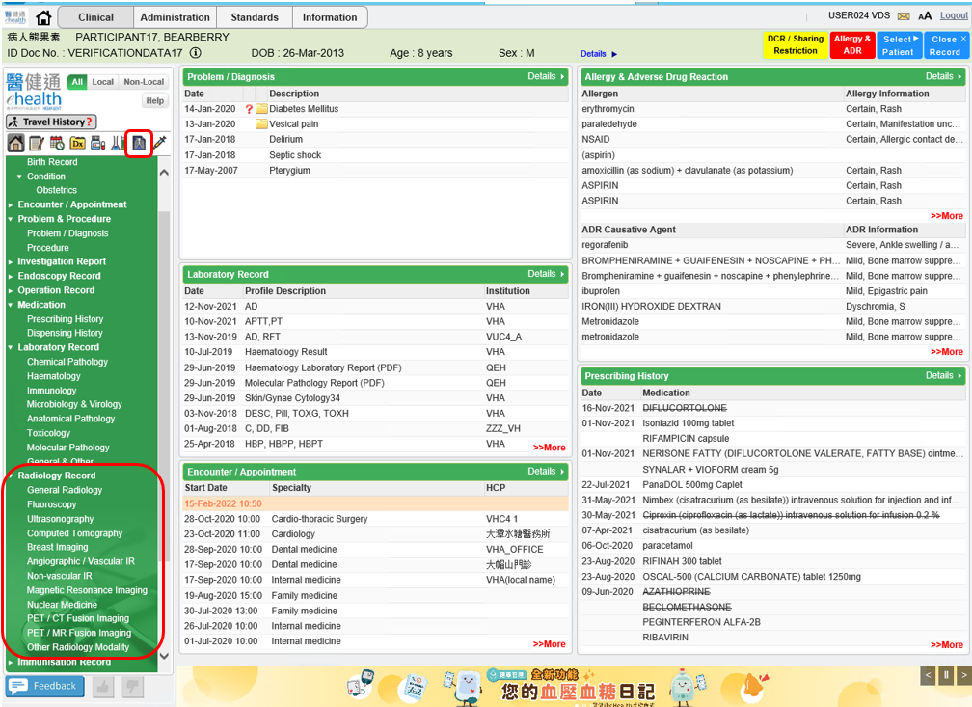

The eHR Value of radiology modality code specific by HCP will display corresponding eHR description in submenu as below:

| **eHR Value** | **eHR Description** | **Full Description** |
| --- | --- | --- |
| XRAY | General radiology | General radiology |
| FLUOR | Fluoroscopy | Fluoroscopy |
| US | Ultrasonography | Ultrasonography |
| CT | Computed tomography | Computed tomography |
| BI | Breast imaging | Breast imaging |
| ANGIO | Angiographic / vascular IR | Angiographic examination / vascular interventional radiology |
| IR | Non-vascular IR | Non-vascular interventional radiology |
| MRI | Magnetic resonance imaging | Magnetic resonance imaging |
| NM | Nuclear medicine | Nuclear medicine |
| PET/CT | PET / CT fusion imaging | Positron emission tomography / computed tomography fusion imaging |
| PET/MR | PET / MR fusion imaging | Positron emission tomography / magnetic resonance fusion imaging |
| OTHER | Other radiology modality | Other radiology modality |

* + There are two display view for Radiology Record: Date View & Document View. In Radiology Record Date View, filters of **modality** and **period** are provided for searching the records or click **‘All Images’** button to show all records with images.

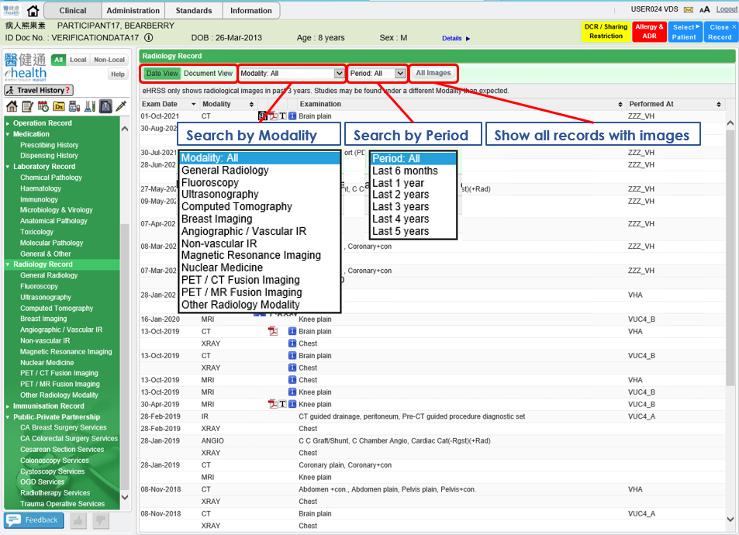

* + In Radiology Record Date View, column “Examination Date”, “Modality Code”, “Examination Name” and “Performing Institution” are displayed with all records and the default sorting sequence are:
    1. Reverse chronological order of examination date, then
    2. Alphabetical order of modality, then
    3. Alphabetical order of examination name

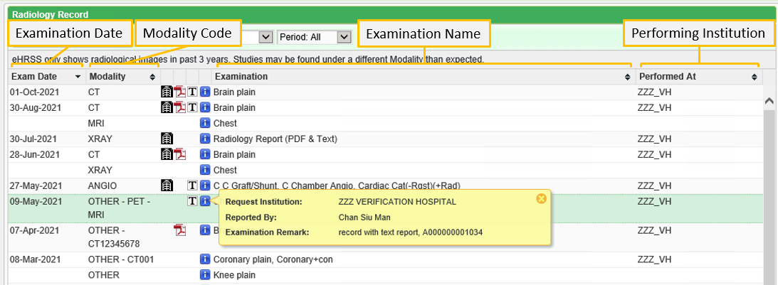

**Rule and logic for display title:**

|  |  |
| --- | --- |
| **Display Title** | **Content** |
| Exam Date | Radiology Examination Date |
| Modality | Radiology Modality Code (eHR Value) |
| Examination | Radiology Examination.  If Level 1 or empty, “Radiology Report” will display |
| Performed At | Short description of radiology examination performing institution identifier    If it is not available, local description of performing institution would be shown.  If no performing institution is provided, this field would be blank (Mouseover to show the preferred name) |

**Notations:**

|  |  |
| --- | --- |
|  | Click to view Radiology Image in popup window |
|  | Click to view Radiology PDF in popup screen |
|  | Click to view Radiology TEXT in lower section |
|  | Below additional information will be provided after clicking it:   * Request Institution * Examination Healthcare Staff * Reported By * Remark |

* + By clicking record with **‘T’ (TEXT) icon**, Radiology Text Report will display in lower section.

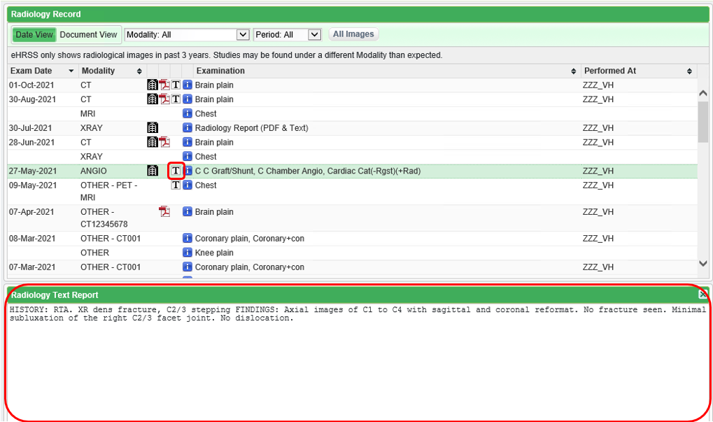

* + By clicking record with **BOTH** **‘PDF’ icon** and **‘T’ (TEXT) icon**, Radiology Text Report will display in lower section and reminder “Report in PDF is available. Click PDF Icon to open” will display.

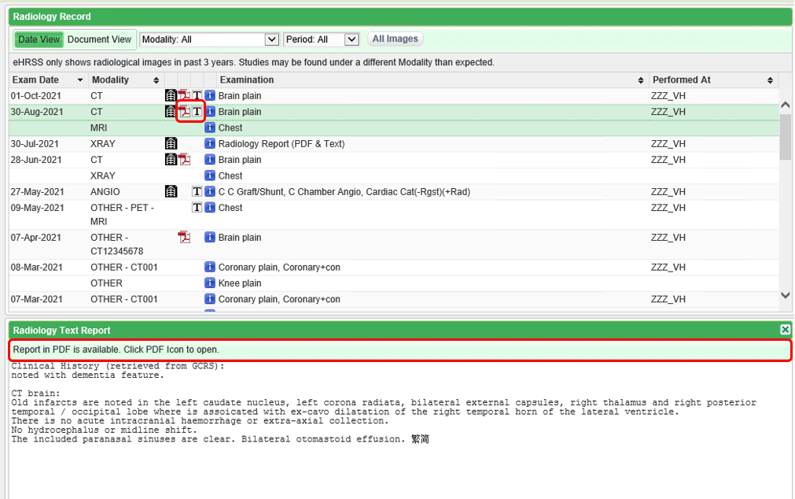

* + By clicking record with **‘PDF’ icon ONLY**, reminder “No text record. Report in PDF is available. Click PDF Icon to open” will display in lower section.

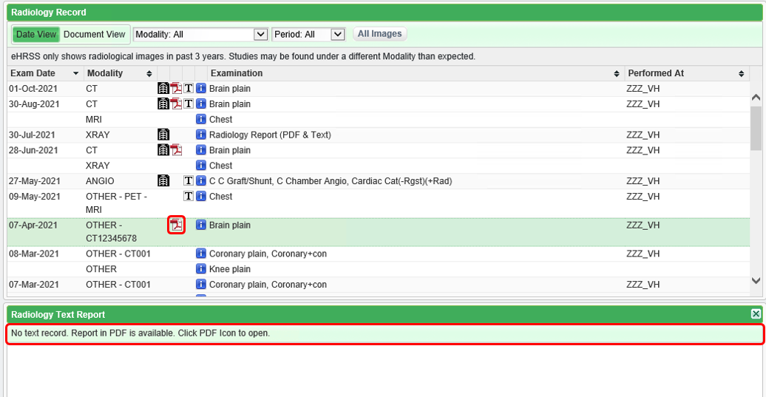

* + By clicking **‘PDF’ icon**, Document Viewer will pop up to show the report.

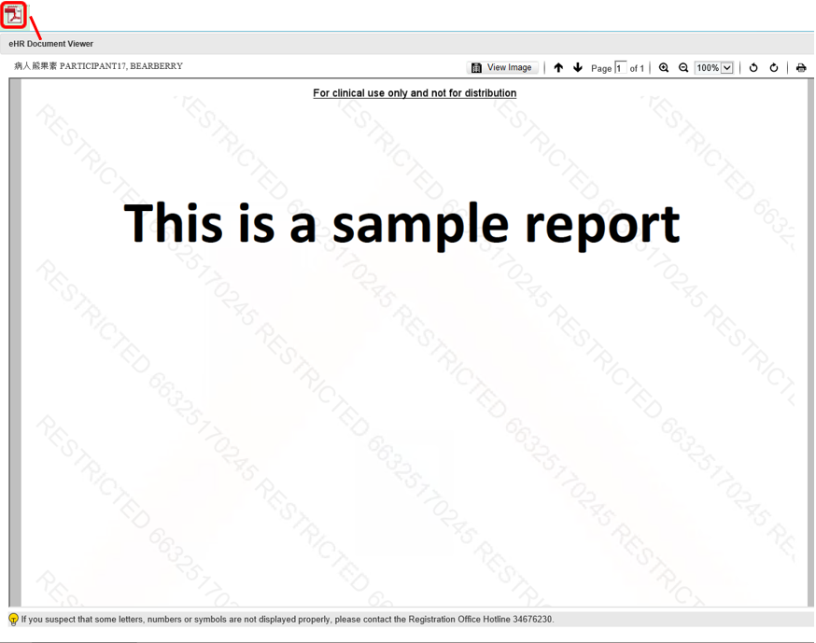

* + By clicking **‘Image’ icon** in Date View or **‘View image’** button in Document View, Image Viewer will pop up to show the image.

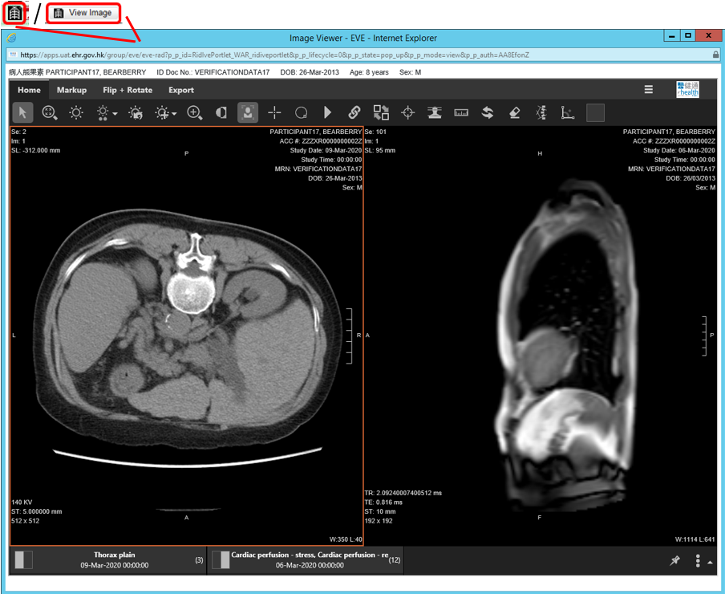

* + By clicking **‘All Image’** button in Date View, Image Panel will display and multiple image studies is available with up to 4 images at the same time.

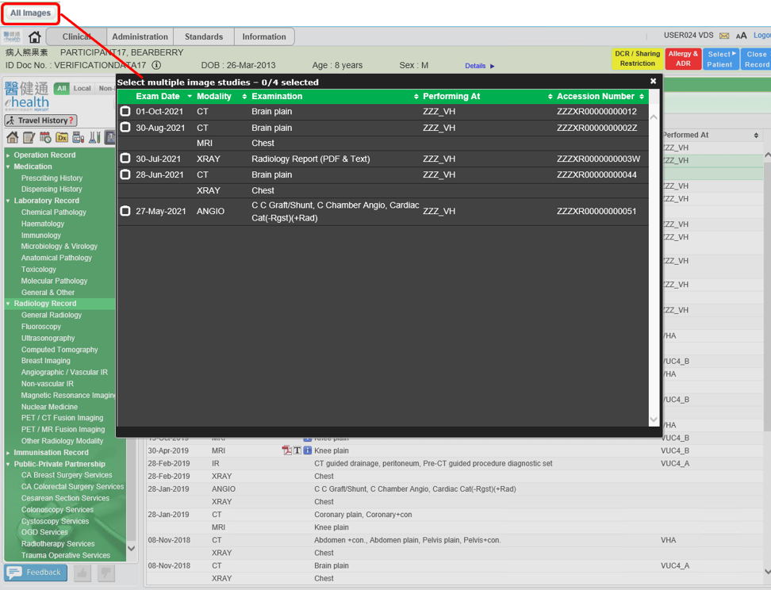

* + By clicking  for the image(s) that want to study to , then click selected row for trigger image viewer to display in separate window.

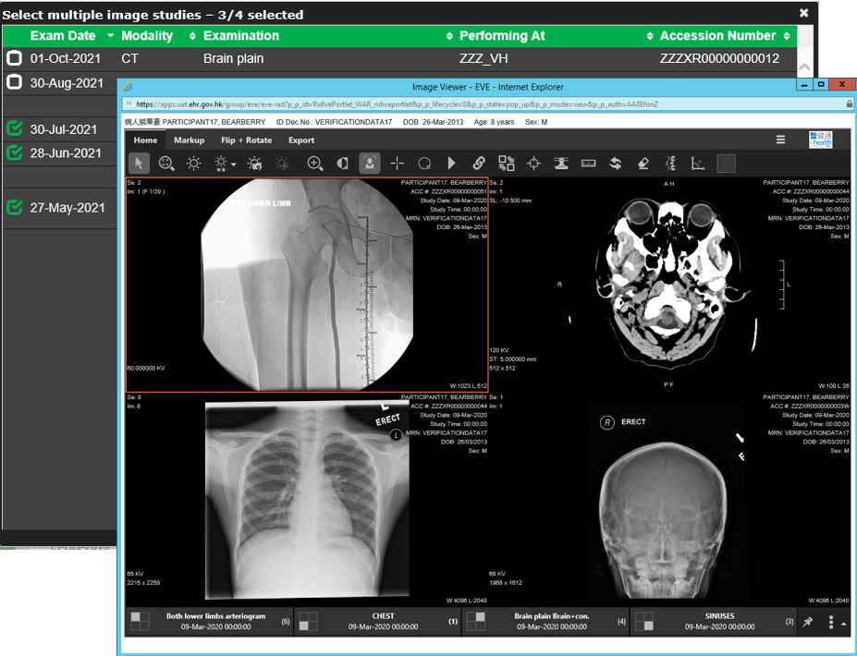

* + In Radiology Record Document View, filters of **modality** and **period** are provided for searching the records or click **‘View Image’** button to open image viewer. Each record display fields “Modality Code + “-” + Examination Name”, “Examination Date” and “Performing Institution” and record list display with default sorting sequence as below:
    1. Reverse chronological order of examination date, then
    2. Alphabetical order of modality, then
    3. Alphabetical order of examination name

The report title is display in the bottom of the viewer after clicking corresponding record.

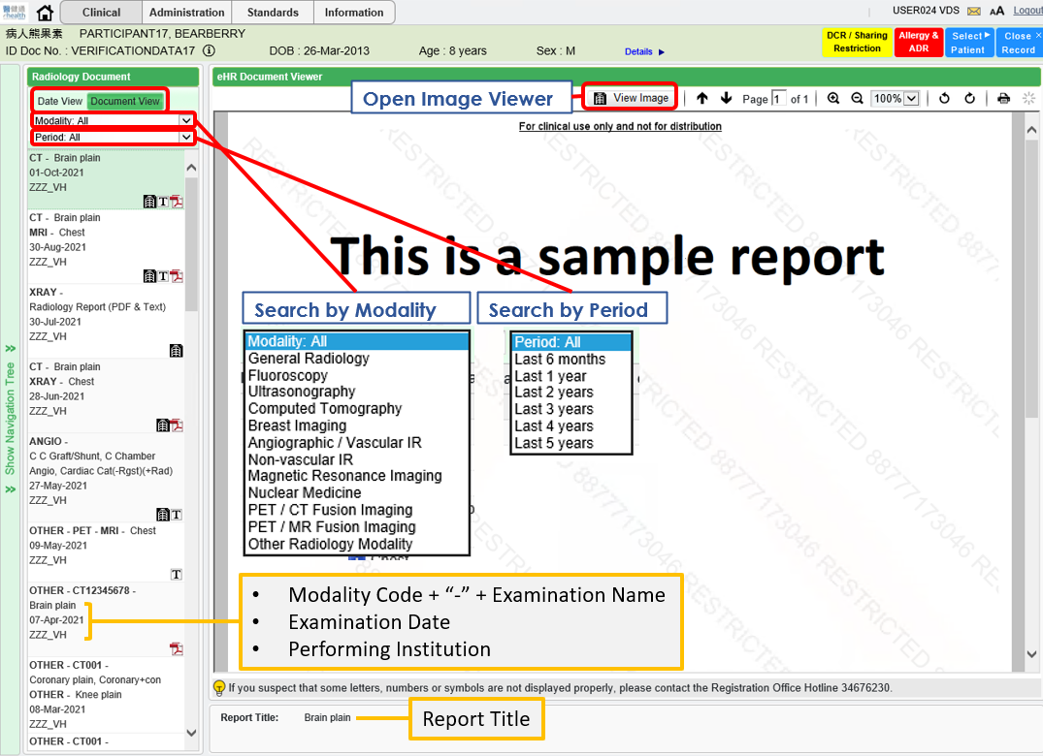

* + By clicking **‘T’ (TEXT) icon**, Text Report will show in viewer panel.

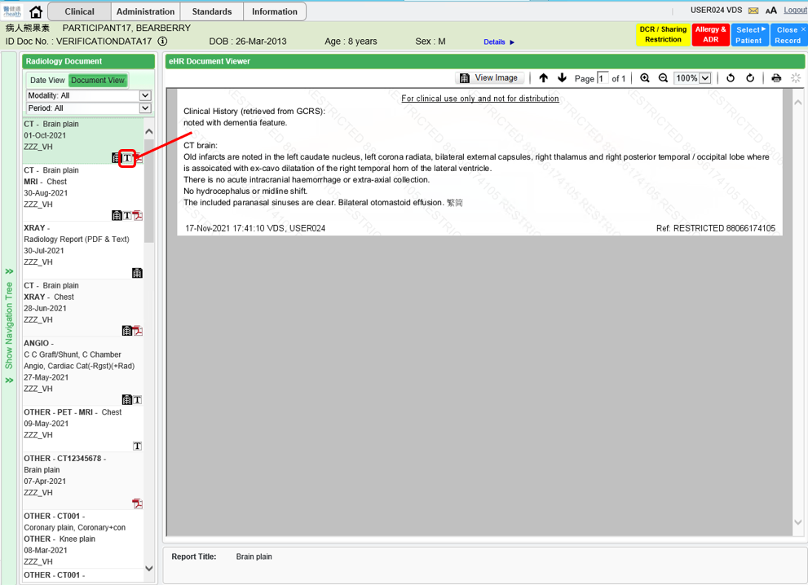

* + By clicking **‘PDF’ icon**, PDF Report will show in viewer panel.

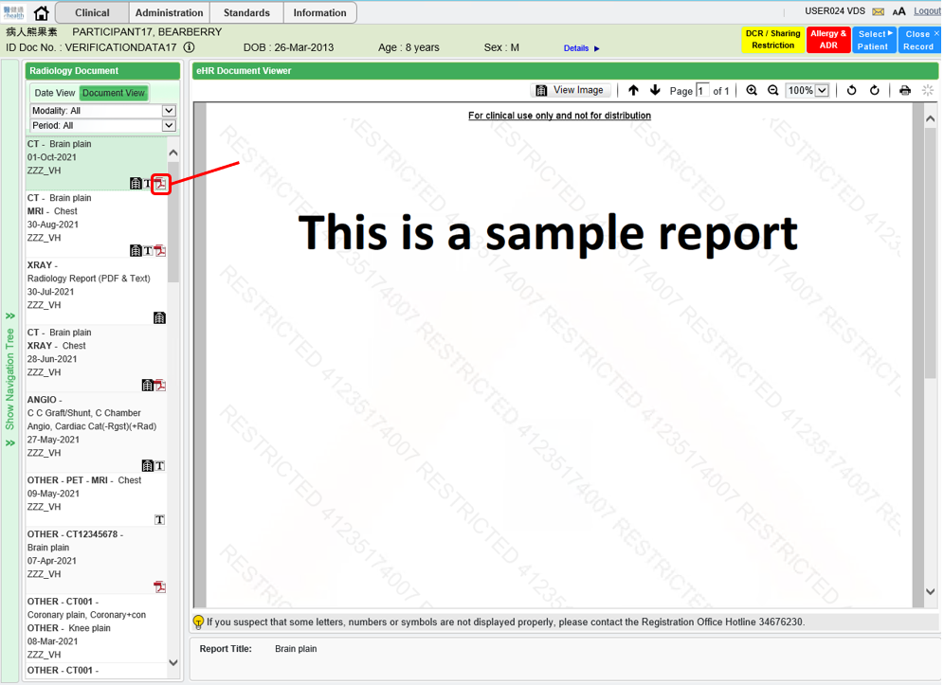

* + By clicking **‘Image’ icon** or **‘View image’** button, Image Viewer will pop up to show the image.

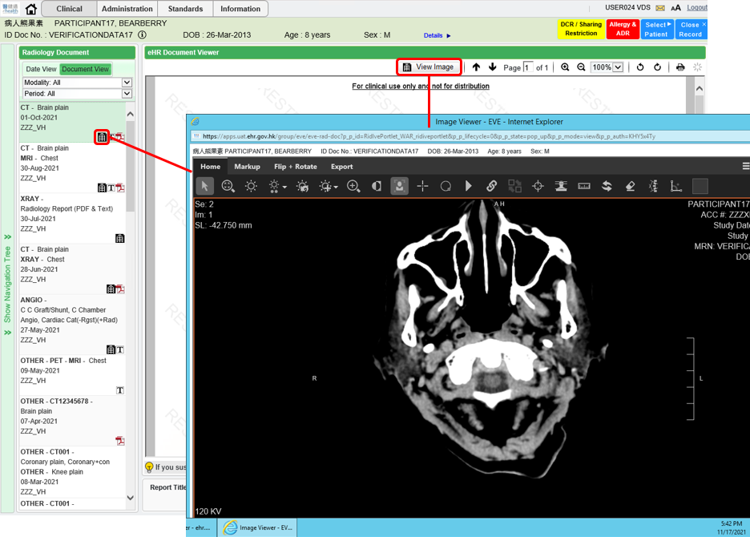

# Appendix – Actual Data Values (Sample)

If the actual values entered are various from the test case, please provide actual values as below.

If the value is not inputted, please use [BLANK] to indicate that empty value is inputted intentionally.

